A Visualization of the Effects of Experimenter Bias on Subject’s Success Ratings

Data Visualization Project

PSYC 3031A

Dr. Monique Herbert

Serena Darking, 215669039

Peyman Moghimi, 216487944

November 4th, 2020

**Code for the Visualization**

**library**(car)

## Loading required package: carData

**library**(psych)

##   
## Attaching package: 'psych'

## The following object is masked from 'package:car':  
##   
## logit

**library**(here)

## here() starts at /Users/serenadarking/OneDrive/R Projects/Data Visualization/Data Visualization

**library**(tidyverse)

## ── Attaching packages ─────────────────────────────────────── tidyverse 1.3.0 ──

## ✓ ggplot2 3.3.2 ✓ purrr 0.3.4  
## ✓ tibble 3.0.3 ✓ dplyr 1.0.2  
## ✓ tidyr 1.1.2 ✓ stringr 1.4.0  
## ✓ readr 1.3.1 ✓ forcats 0.5.0

## ── Conflicts ────────────────────────────────────────── tidyverse_conflicts() ──  
## x ggplot2::%+%() masks psych::%+%()  
## x ggplot2::alpha() masks psych::alpha()  
## x dplyr::filter() masks stats::filter()  
## x dplyr::lag() masks stats::lag()  
## x dplyr::recode() masks car::recode()  
## x purrr::some() masks car::some()

*#Loading the file Adler.csv found in a folder called "data."*  
experimenter_bias <- **read_csv**(file=**here**("data", "Adler.csv"))

## Warning: Missing column names filled in: 'X1' [1]

## Parsed with column specification:  
## cols(  
## X1 = col_double(),  
## instruction = col_character(),  
## expectation = col_character(),  
## rating = col_double()  
## )

**view**(experimenter_bias)  
  
*#Gathering descriptive statistics for the above data grouped by*   
*#instruction and expectation.*  
**describeBy**(x = experimenter_bias**$**rating,  
 group = **list**(experimenter_bias**$**instruction,  
 experimenter_bias**$**expectation))

##   
## Descriptive statistics by group   
## : good  
## : high  
## vars n mean sd median trimmed mad min max range skew kurtosis se  
## X1 1 18 4.44 15.4 4.5 3.75 13.34 -22 42 64 0.47 -0.02 3.63  
## ------------------------------------------------------------   
## : none  
## : high  
## vars n mean sd median trimmed mad min max range skew kurtosis se  
## X1 1 18 -9.83 14.72 -10 -10.12 15.57 -37 22 59 0.17 -0.61 3.47  
## ------------------------------------------------------------   
## : scientific  
## : high  
## vars n mean sd median trimmed mad min max range skew kurtosis se  
## X1 1 18 -6.94 8.45 -4.5 -6.62 5.93 -24 5 29 -0.74 -0.47 1.99  
## ------------------------------------------------------------   
## : good  
## : low  
## vars n mean sd median trimmed mad min max range skew kurtosis se  
## X1 1 18 -18.28 10.3 -22 -19.44 3.71 -30 12 42 1.53 1.74 2.43  
## ------------------------------------------------------------   
## : none  
## : low  
## vars n mean sd median trimmed mad min max range skew kurtosis se  
## X1 1 18 -3.5 11.63 -5 -3.5 9.64 -27 20 47 0.1 -0.51 2.74  
## ------------------------------------------------------------   
## : scientific  
## : low  
## vars n mean sd median trimmed mad min max range skew kurtosis se  
## X1 1 18 0.83 10.46 -1 1.38 11.12 -22 15 37 -0.25 -0.92 2.46

*#Creating a data frame called sample size to include it in the code below.*  
*#This is so we can display the sample sizes of each group on our plot.*   
sample_size = experimenter_bias **%>%**   
 **group_by**(instruction,expectation)**%>%**  
 **summarize**(num=**n**())

## `summarise()` regrouping output by 'instruction' (override with `.groups` argument)

*#Creating a pipeline so everything below "experimenter_bias" is related to*  
*#the experimenter_bias dataframe.*  
experimenter_bias**%>%**  
 **left_join**(sample_size) **%>%** *#left_join includes all rows that are apart of t#he sample_size dataframe.mutate allows us to create new variable while prese#rving the values in the #data frame still.In this case we want to create sam#ple size variables.*   
 **mutate**(instruction = **paste0**(instruction, "\n", "n=", num)) **%>%** *#paste0 #con#verts the argument"n="* *into character strings.*

*#ggplot allows us to create plots. For this study we used a boxplot(geom_boxp#lot) for visualization to illustrate the increase or decrease in average rat#ings as a result of the instructions participants received grouped by the pa#rticipants (experimenters) expected average succ#ess ratings of subjects."*  
 **ggplot**(experimenter_bias,mapping = **aes**(x= instruction, y=rating,fill=expectation))**+**  
 *#adding some customizations to the boxplot to make it look clearer and emph#asize where the outliers are.*   
 **geom_boxplot**( color="blue",  
 fill="blue",  
 alpha=0.2, notch=FALSE,  
 notchwidth = 0.8,  
 outlier.colour="red",  
 outlier.fill="red",  
 outlier.size=3)**+**  
 *#geom_jitter allows us to illustrate each "subject's" average success ratin#gs of people in photographs.*   
 **geom_jitter**(color="grey", size=0.7, alpha=0.5) **+**  
 *#coord_cartesian allows us to see the graph clearly as well as set limits*

*#on the axes.*   
 **coord_cartesian**(ylim=**c**(**-**40, 40)) **+**   
 *#scale_y_continuos allows us to set specified breaks on the y axis,*   
 *#specifically 10 in this case.*   
 **scale_y_continuous**(breaks=**seq**(**-**40, 40, 10))**+**  
 *#labs was used to change the names for the axes labels, legend, title, and #subtitle of the plot.*   
 **labs**(y="Average Success Rating", x="Instructions Received",   
 title= "The influence of experimenter bias on average ratings of success",  
 subtitle="Table 1",  
 fill = "Expected Rating")**+**  
 *#facet_wrap puts the plot into panels grouped by participants’ expected ratin#gs to better illustrate the change in average success ratings.*   
 **facet_wrap**(**~**expectation)**+**  
 *#theme_bw applies a theme to the plot.*   
 **theme_bw**() **+**   
 *#theme allows for changes in the theme of the plot. Assigning element_blank#()* *to the grid lines allows the gridlines to be blank so the plot is in APA #style.The axes lines were also changed to a darker black.*   
 **theme**(panel.grid.major = **element_blank**(),  
 panel.grid.minor = **element_blank**(),   
 axis.line = **element_line**(colour = "black"))

## Joining, by = c("instruction", "expectation")

**Visualization Question:** Does experimenter instruction significantly bias the data they collect toward or away from the results they expect?

**Description of the Data**

A sample of 108 participants, who were the “subjects” in the study, were asked to complete a person perception task, where they each rated 10 photos of people on the amount of success the subjects perceived the people to be feeling (extreme failure to extreme success). However, the study was really focused on the 6 “experimenters” of the study, who collected the perceived success ratings from the subjects. Each experimenter was assigned a group of subjects (*n* = 18) and details regarding the expected rating from each subject. The expected ratings were labeled “expectations,” meaning whether they have the tendency to rate success “high” or “low.” In addition, the experimenters received instructions on how to collect data. A third of the experimenters were instructed to collect data that agreed with scientist expectations, the group being labeled “good.” Another third were instructed to collect data while strictly adhering to proper methods of collection, the group being labeled “scientific.” Lastly, a third were not given any further instructions (control). Experimenters in the “good” data condition were instructed to collect results that the researchers are looking for and experimenters in the “scientific” data condition were instructed to collect data using proper procedure. The data collected by the experimenters are labeled “Rating.”

**Goals and Outcomes**

The visualization project was conducted with two main objectives in mind. The first and main objective was to answer our question, “does experimenter instruction significantly bias the data they collect toward or away from the results they expect?” The visualization shows a clear difference between groups with respect to average ratings. As shown in Figure 1, participants/subjects in the *high x good* condition gave higher perceived success ratings compared to those in the *high x scientific* and *high x none* conditions, which suggested that experimenters who were told to gather “good” results and were expecting higher ratings from the participants biased participants toward the expected higher perceived success ratings. Participants in the *low x good* conditions gave lower perceived success ratings compared to those in the *low x scientific* and *low x none* conditions, which suggested that experimenters who were told to gather “good” results and were expecting lower ratings from the participants biased participants toward the expected lower perceived success ratings. Mean scores and standard deviations of each condition can be seen in Table 1. What these results show is that experimenters have the potential to sway participants in a certain direction when they hold certain biases and expectations. A factorial ANOVA design should be conducted to find out if the relationships between the groups are truly meaningful and significantly different.

.

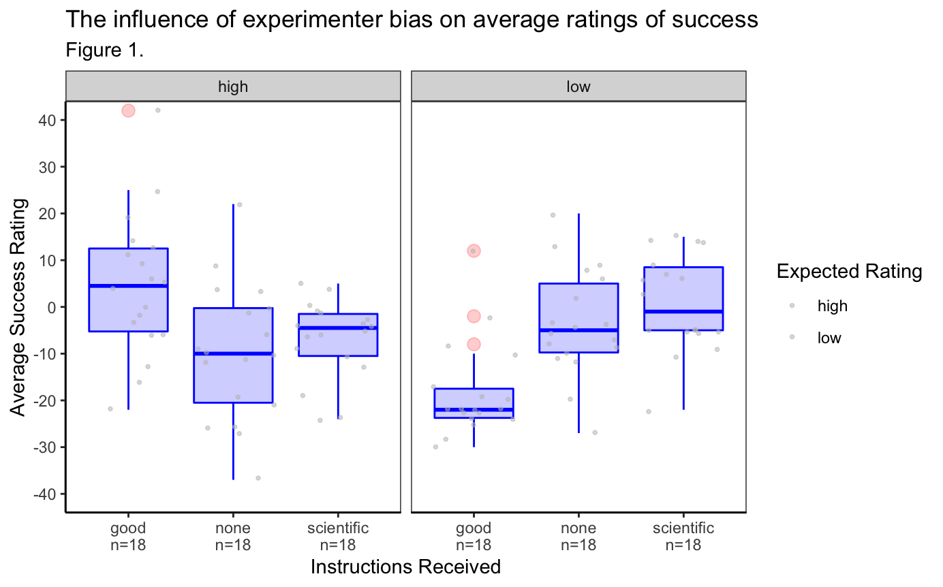

Table 1.

*Means and standard deviations for rating as a function of a 3(instruction) X 2(expectation) design*

|  |  |  |  |  |
| --- | --- | --- | --- | --- |
|  | expectation | | | |
|  | high | | low | |
| instruction | *M* | *SD* | *M* | *SD* |
| good | 4.44 | 15.40 | -18.28 | 10.30 |
| none | -9.83 | 14.72 | -3.50 | 11.63 |
| scientific | -6.94 | 8.45 | 0.83 | 10.46 |

*Note.* *M* and *SD* represent mean and standard deviation, respectively.

The second objective is the visualization of data for the sake of checking the assumptions needed for validity of data testing, namely, the assumption of normality and the homogeneity of variance. The box plot shows slightly skewed distributions, especially for the *low x good* and *high x* *scientific* interaction effects. In addition, each boxplot has many outlier data points. This meant that the assumptions of normality and homogeneity of variance could not be confidently made. For a better understanding of the homogeneity of variance assumption, Levene’s test is recommended to be conducted on the data.

**Limitations of the Data**

Though the design of the experiment is factorial in nature, the data available only allows for the visualization of two effects. First were the interaction effects between the independent variables, those being “Instructions” and “Expectations.” Second, the single independent variable effect of “Expectations.” The independent variable “Instructions” included a control level, which allowed for comparison between “High” and “Low” expectations without the “Instructions” variable itself interacting with the resulting data. The lack of a control level within “Expectations” did not allow for visualizing the single variable effect of “Instructions.” Therefore, a major limitation of this data set is that it does not allow for the measurement of single variable effects for both independent variables.

Another limitation of the data is that some of the conditions appear to violate the assumptions of homogeneity of variance. This is a limitation because ANOVA post hoc tests cannot be conducted due to the required assumption of homogeneity of variance not being met. Despite this limitation, the data does appear to meet the assumption of normality with the data only being only slightly skewed. Still, if homogeneity of variance is not met, analysis can be conducted by ask for a White-Huber correction in a statistical program, like R. Again, further analysis is needed to test the assumption of homogeneity of variance.

The last limitation is the breadth of the project. While visualization of the data clearly shows a difference between the *high x good* and *low x good* conditions, other interaction effects, like *high x scientific* versus *low x scientific* can not be confidently judged. The use of an analysis of variance is needed to truly establish whether the interaction effects are statistically significant. Chart, box and whisker chart
